

ARIS Toolkit WebQuest

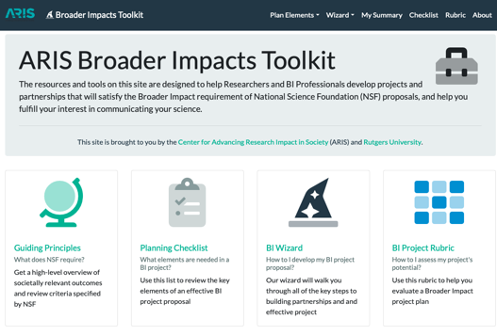

This Web Quest will help you learn about the Broader Impacts (BI)Wizard and how it might help researchers develop projects and partnerships that will satisfy the BI requirement of National Science Foundation (NSF) proposals, and help fulfill their interest in communicating their science.

1. **Watch the walkthrough video:** [**https://aris.marine.rutgers.edu/wizard/wizard.php**](https://aris.marine.rutgers.edu/wizard/wizard.php)**.** **What are the two pathways of the BI Wizard? What is the purpose of each pathway?**
2. **Watch the video on this page -** [**https://aris.marine.rutgers.edu/wizard/intro.php**](https://aris.marine.rutgers.edu/wizard/intro.php)**. What are the five things to consider in a BI plan?**
3. **One of the central goals of BI is to make sure the research benefits society. Go to the plan elements page -** [**https://aris.marine.rutgers.edu/wizard/relevance.php**](https://aris.marine.rutgers.edu/wizard/relevance.php)**. Write down two of your favorite examples of the ten listed areas of societal benefits of research:**
4. **Some researchers may have no idea how to work with a partner on their BI work. Go to** [**https://aris.marine.rutgers.edu/wizard/partners.php**](https://aris.marine.rutgers.edu/wizard/partners.php) **and watch the video. What are the three key things that distinguish a partnership from any other contractual relationships:**
   1. Bonus points for the name of the professor speaking about partnerships:________________________

1. **One of the most important things to consider is the needs of the audience the researcher is engaging. Understanding the audiences' needs and motivations for working with you will not only make a more compelling case (rationale) for funding a BI project, but it will also make for a positive connection and experience when funded. Watch this video** [**https://aris.marine.rutgers.edu/wizard/audiences.php**](https://aris.marine.rutgers.edu/wizard/audiences.php)**.**

**What are the three variables to think about when determining your audience?**

1. **Go to** [**https://aris.marine.rutgers.edu/wizard/audiences.php**](https://aris.marine.rutgers.edu/wizard/audiences.php)**. Choose one audience and list one reference you can use in your proposal and one way to engage them:**
   1. Reference:
   2. How will you engage them?
2. **Go to** [**https://aris.marine.rutgers.edu/wizard/cost.php**](https://aris.marine.rutgers.edu/wizard/cost.php) **and play the higher lower game. What was your score?**
3. **A truly successful BI project engages people outside the field to understand the relevance of the research. BI activities are an excellent mechanism to not only engage the public, but also to demonstrate accountability with public funds. In this section of the Wizard, you can find evaluation resources that help tell the story of the impact of your BI project.   
   See** [**https://aris.marine.rutgers.edu/wizard/evaluation.php**](https://aris.marine.rutgers.edu/wizard/evaluation.php)**.   
   Watch this video** [**https://www.youtube.com/watch?v=5P7UpWD66I8**](https://www.youtube.com/watch?v=5P7UpWD66I8)**.   
     
   What are the three types of evaluation:**

**Save this worksheet for our discussion on Nov 16th!**